Deepika AG

Module END Assignment 2 – MY SQL

AIM

To analyze the e-commerce customer data using SQL to identify patterns in customer behavior, order activity, churn status, complaints, payment preferences, delivery distance, and return details, and to derive meaningful insights from the data.
Data Cleaning:
- Impute mean for the following columns, and round off to the nearest integer if
required: WarehouseToHome, HourSpendOnApp, OrderAmountHikeFromlastYear,
DaySinceLastOrder.

Answ : Mean means the average value of a column. First, I calculate the average of the specified column using AVG(). Then, using the UPDATE function, I replace the NULL values with the rounded average value directly.

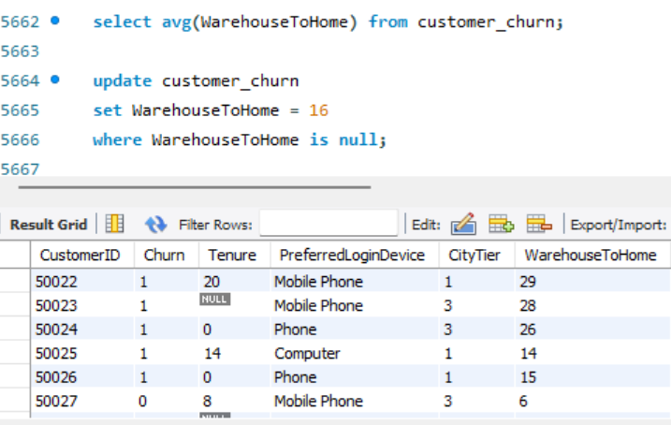

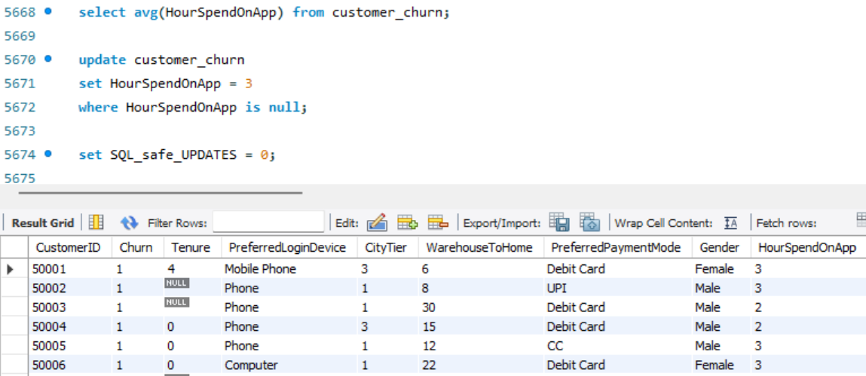

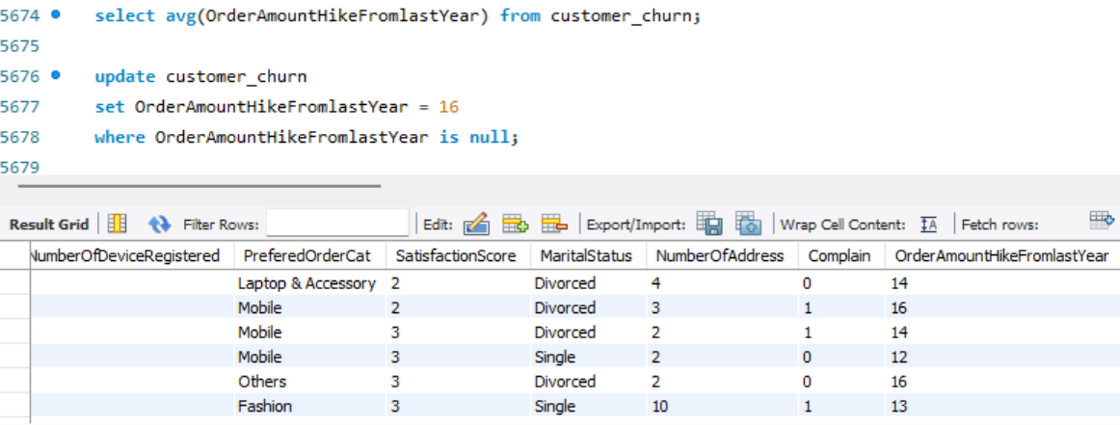

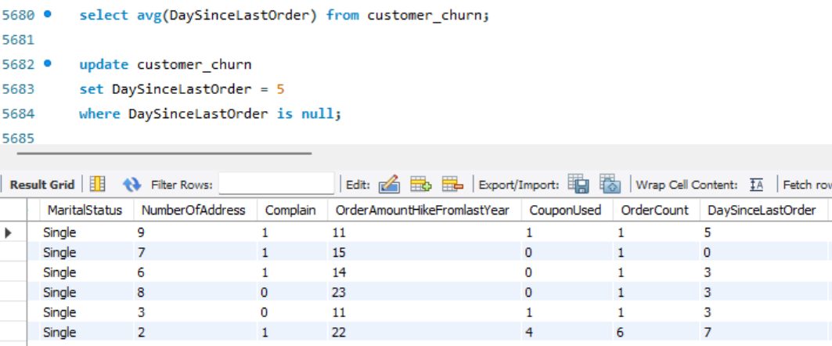

- Impute mode for the following columns: Tenure, CouponUsed, OrderCount.

Answ : Mode means the most frequently occurring value in a column. First, I count the occurrences of each value in the specified column using COUNT(). Then, I group the column using GROUP BY and sort the results in descending order using ORDER BY. The value with the highest count is the mode. I then use that mode value to replace the NULL values in the column.

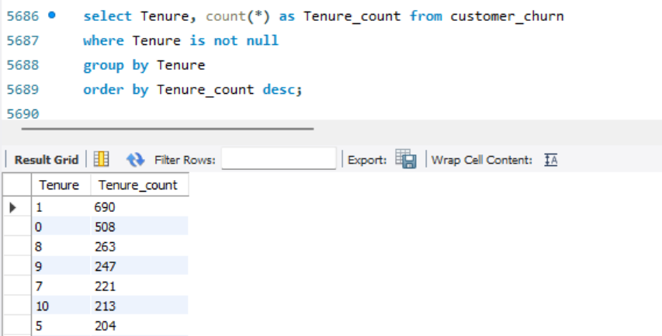

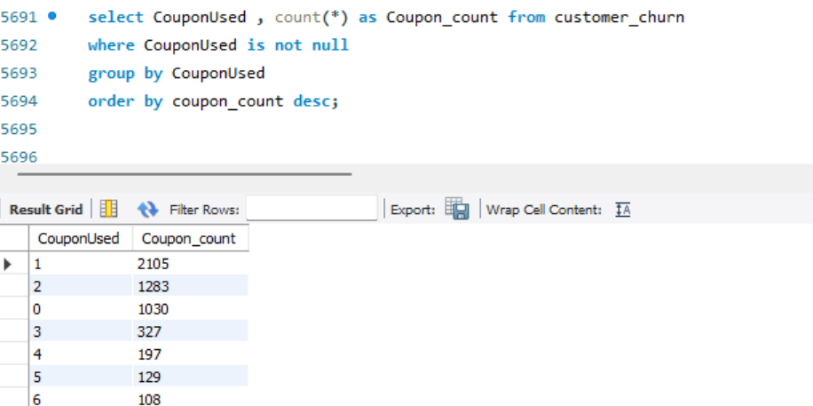

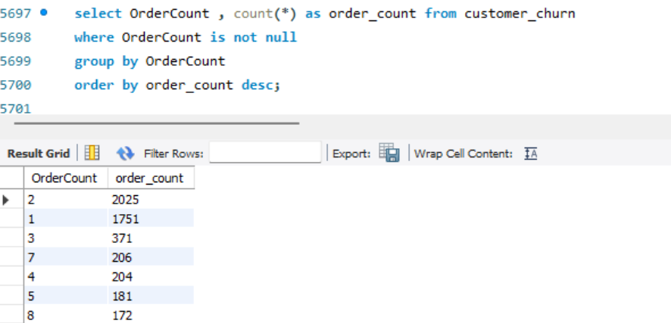

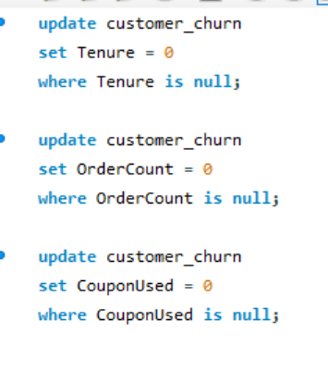

- Handle outliers in the 'WarehouseToHome' column by deleting rows where the values are greater than 100.
To handle outliers, first I identify the rows where WarehouseToHome is greater than 100 using the
WHERE condition. Then I delete those rows using the DELETE statement.

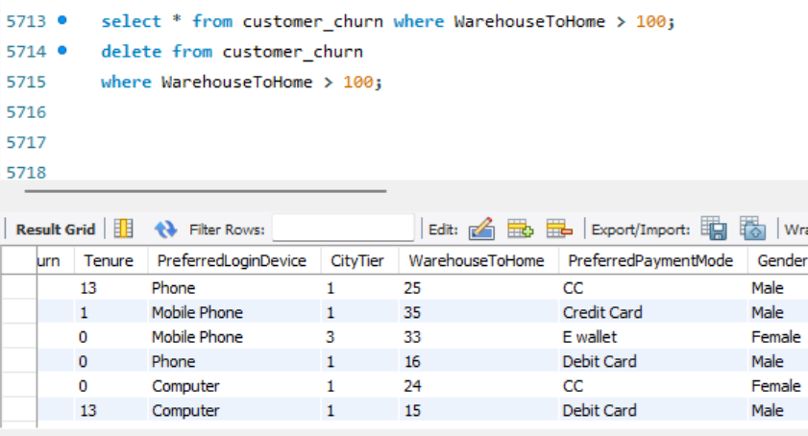

Dealing with Inconsistencies:
- Replace occurrences of “Phone” in the 'PreferredLoginDevice' column and “Mobile” in the 'PreferedOrderCat' column with “Mobile Phone” to ensure uniformity.
Here I used Update function

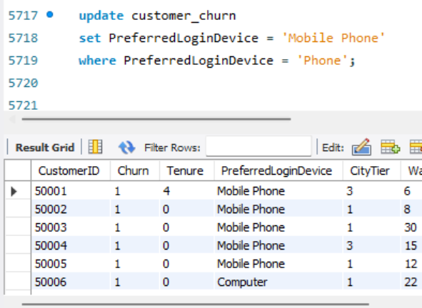

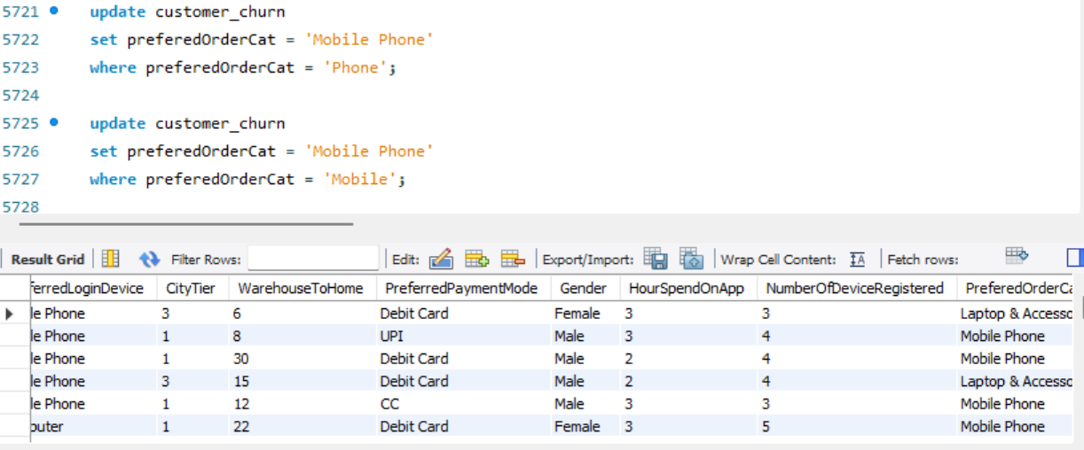

- Standardize payment mode values: Replace "COD" with "Cash on Delivery" and "CC" with "Credit Card" in the PreferredPaymentMode column.

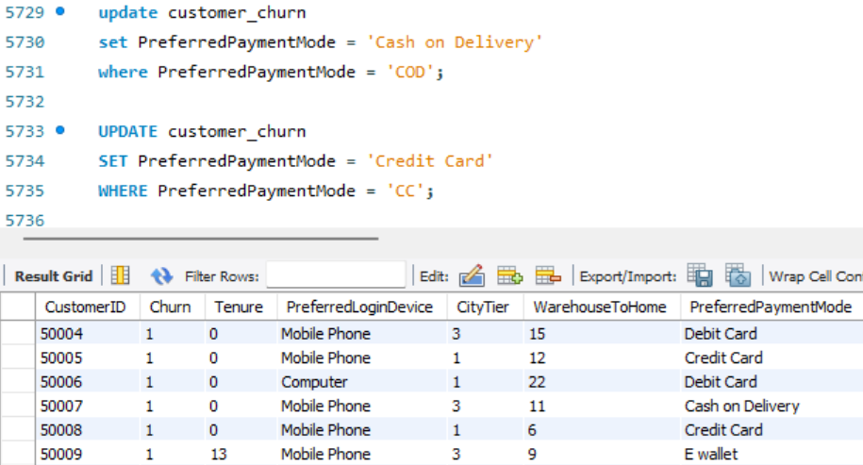

Data Transformation:

- Rename the column "PreferedOrderCat" to "PreferredOrderCat".

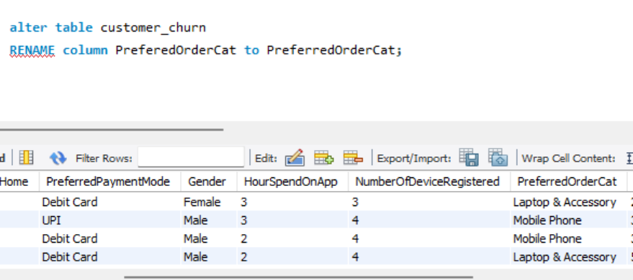

- Rename the column "HourSpendOnApp" to "HoursSpentOnApp".
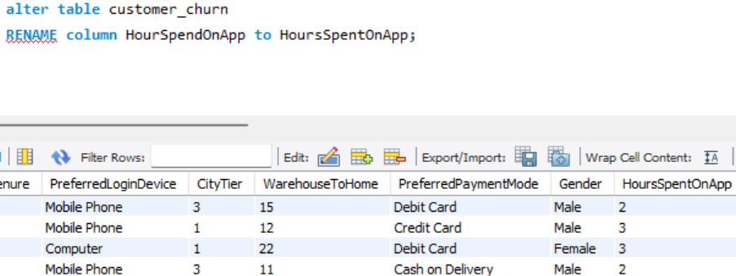

Creating New Columns:
- Create a new column named ‘ComplaintReceived’ with values "Yes" if the corresponding value in the ‘Complain’ is 1, and "No" otherwise.

I added a new column ‘‘ComplaintReceived’ using ADD function and by using Update function set values as “Yes” or ‘No’ as shown below.

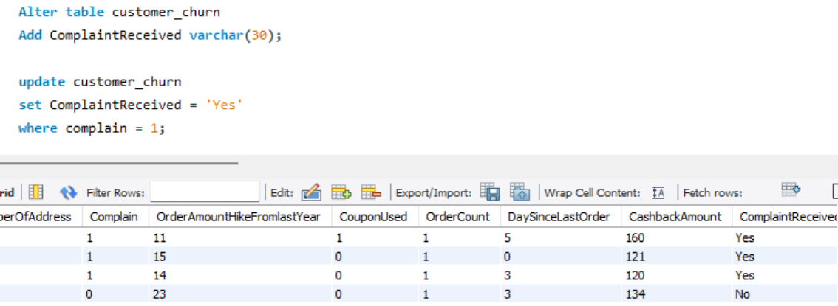

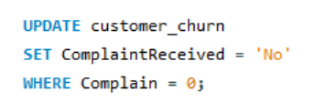

- Create a new column named 'ChurnStatus'. Set its value to “Churned” if the corresponding value in the 'Churn' column is 1, else assign “Active”.

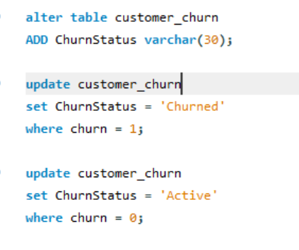

OUTPUT

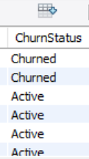

Column Dropping:

- Drop the columns "Churn" and "Complain" from the table.
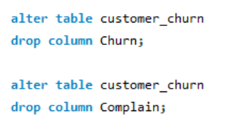

Data Exploration and Analysis:
- Retrieve the count of churned and active customers from the dataset.
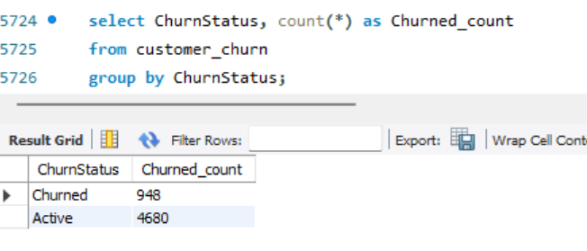

- Display the average tenure and total cashback amount of customers who churned.

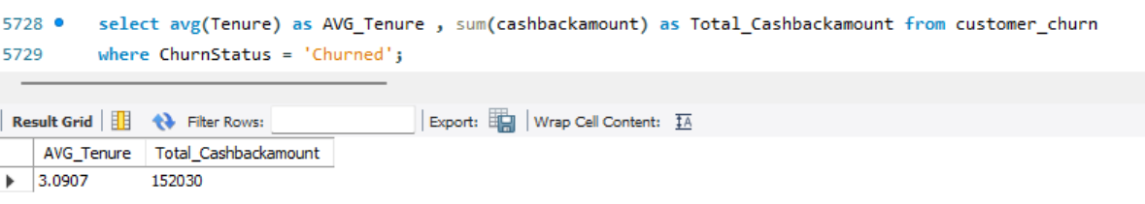

- Determine the percentage of churned customers who complained.

SUM(ComplaintReceived = 'Yes') counts the churned customers who submitted a complaint, while
COUNT(*) gives the total number of churned customers. Multiplying by 100 converts the result into a
percentage.

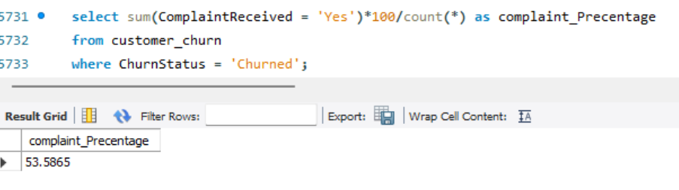

- Identify the city tier with the highest number of churned customers whose preferred order category is Laptop & Accessory.

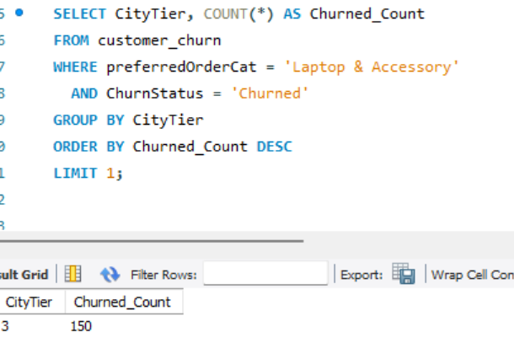

Here, I counted the customers based on the preferred order category “Laptop & Accessory” and “Churned” status. I grouped the results by CityTier and ordered the count in descending order to get the highest count first. Finally, I used LIMIT 1 to display only the CityTier with the highest number of churned customers.

- Identify the most preferred payment mode among active customers.

Here, I counted the customers based on “Active” status and grouped the results by PreferredPaymentMode. I then ordered the count in descending order to get the highest count first. Finally, I used LIMIT 1 to display only the PreferredPaymentMode with the highest number of active customers.

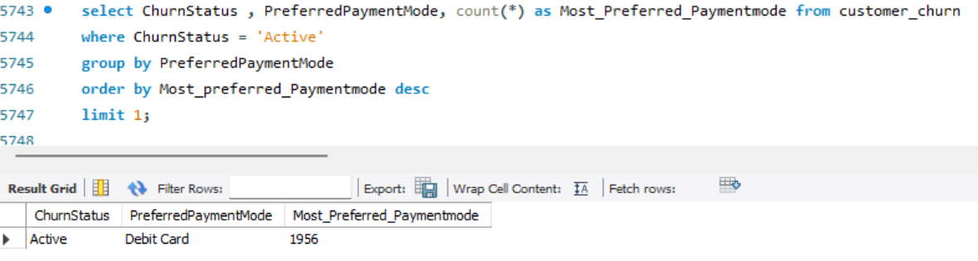

- Calculate the total order amount hike from last year for customers who are single and prefer mobile phones for ordering.
Here, I calculated the total order amount hike from last year using the SUM() function. I filtered the customers based on “Single” marital status and “Mobile Phone” as their preferred login device.
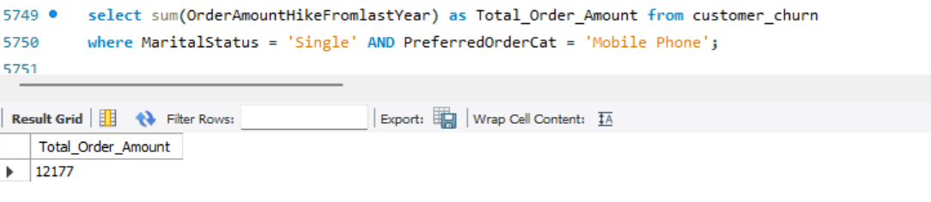

- Find the average number of devices registered among customers who used UPI as their preferred payment mode.
Here I calculated Average Number of Device Registered using AVG() Function. I filtered the customers based on Preferred Payment Mode as “UPI’

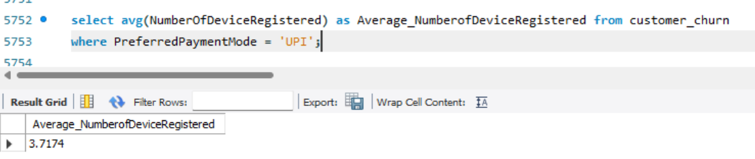

- Determine the city tier with the highest number of customers.
Here, I counted the number of customers for each CityTier using the COUNT() function. I grouped the results by CityTier and ordered the count in descending order to get the highest count first. Finally, I used LIMIT 1 to display only the CityTier with the highest number of customers.

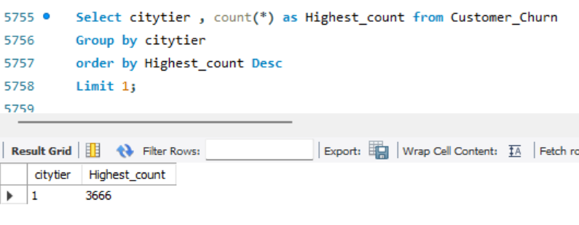

- Identify the gender that utilized the highest number of coupons.
Here, I calculated the total number of coupons used by each gender using the SUM() function. I grouped the results by Gender and ordered the total coupon count in descending order. Finally, I used LIMIT 1 to display the gender that utilized the highest number of coupons.

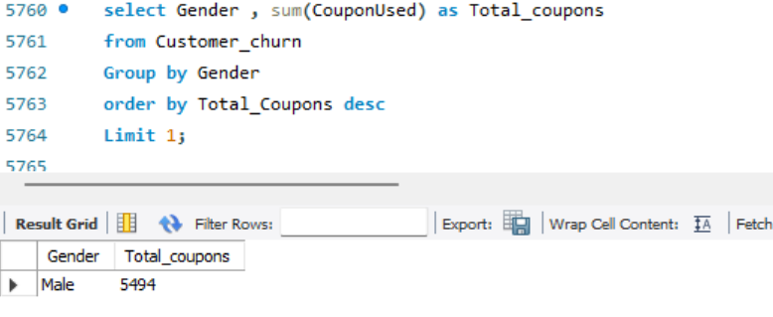

- List the number of customers and the maximum hours spent on the app in each preferred order category.

Here, I counted the number of customers using COUNT(CustomerID) and calculated the maximum hours spent on the app using MAX(HoursSpentOnApp). I grouped the results by PreferredOrderCat to get the customer count and maximum hours separately for each preferred order category.

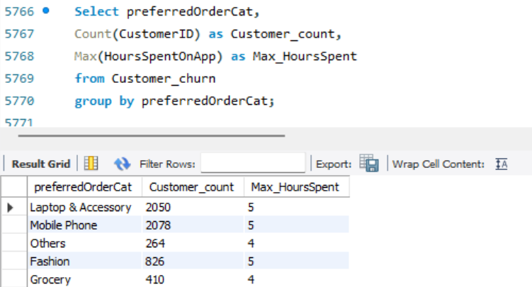

- Calculate the total order count for customers who prefer using credit cards and have the maximum satisfaction score.

Here, I calculated the total order count using the SUM() function for customers who prefer Credit Card as their payment mode. I used a subquery with the MAX() function to find the highest satisfaction score and filtered the customers who have that maximum satisfaction score.

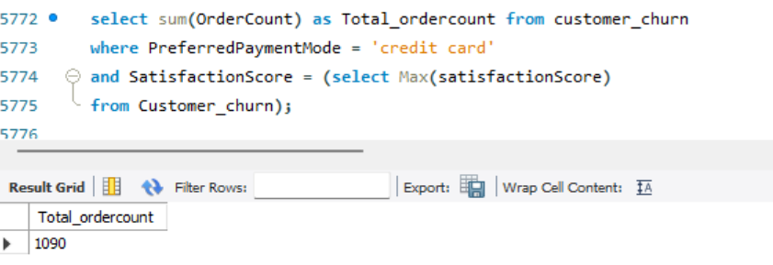

- What is the average satisfaction score of customers who have complained?

Here, I calculated the average satisfaction score using the AVG() function. I filtered the customers based on ComplaintReceived = 'Yes' using the WHERE condition to consider only customers who have complained.

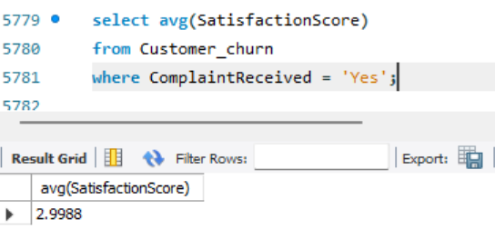

- List the preferred order category among customers who used more than 5 coupons.

Here, I selected the PreferredOrderCat column to identify the preferred order category of customers who used more than 5 coupons. I used the WHERE condition CouponUsed > 5 to filter those customers.

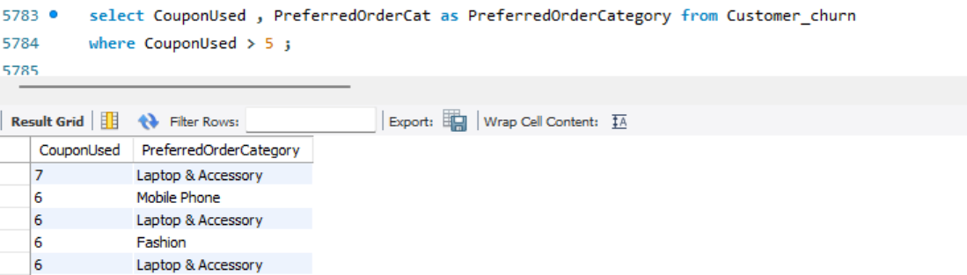

- List the top 3 preferred order categories with the highest average cashback amount.

Here, I calculated the average cashback amount for each preferred order category using the AVG() function. I grouped the results by PreferredOrderCat and ordered the average cashback amount in descending order to get the highest averages first. Finally, I used LIMIT 3 to display the top 3 preferred order categories with the highest average cashback amount.

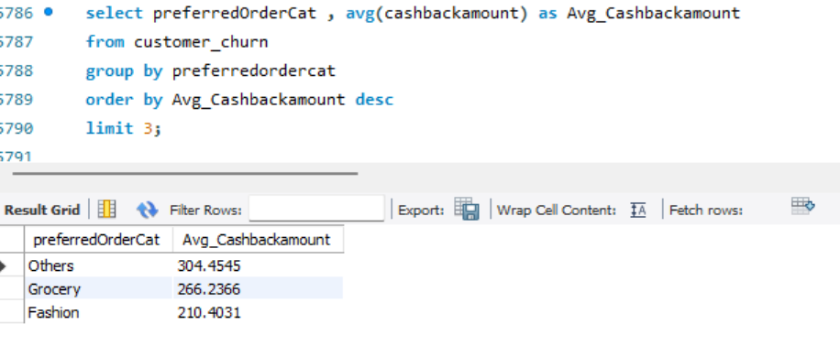

- Find the preferred payment modes of customers whose average tenure is 10 months and have placed more than 500 orders.

Here, I calculated the average tenure using the AVG() function and the total number of orders using the SUM() function. I grouped the customers based on their PreferredPaymentMode. I used ROUND() to consider payment modes whose average tenure rounds to 10 months, and used HAVING to filter payment modes with more than 500 total orders.

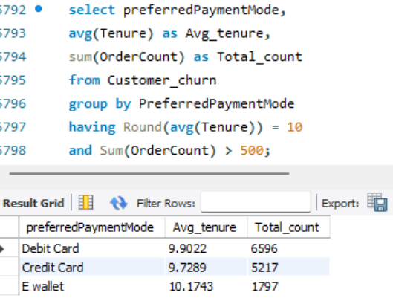

- Categorize customers based on their distance from the warehouse to home such as 'Very Close Distance' for distances <=5km, 'Close Distance' for <=10km, 'Moderate Distance' for <=15km, and 'Far Distance' for >15km. Then, display the churn status breakdown for each distance category.

Here, I categorized customers based on their WarehouseToHome distance using the CASE statement. I grouped the customers based on their Distance_Category and ChurnStatus. I used the COUNT() function to calculate the number of customers in each group and displayed the churn status breakdown for each distance category.

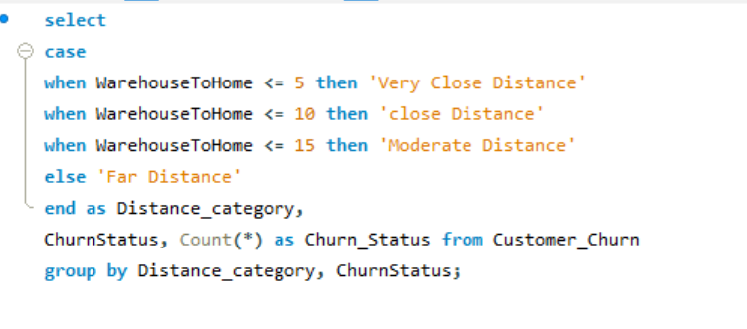

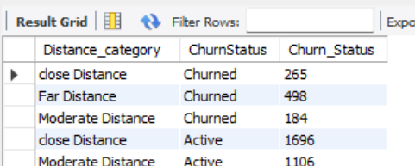

- List the customer’s order details who are married, live in City Tier-1, and their order counts are more than the average number of orders placed by all customers.
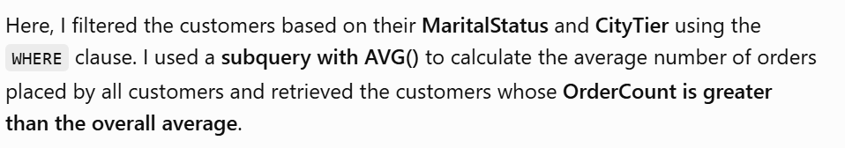
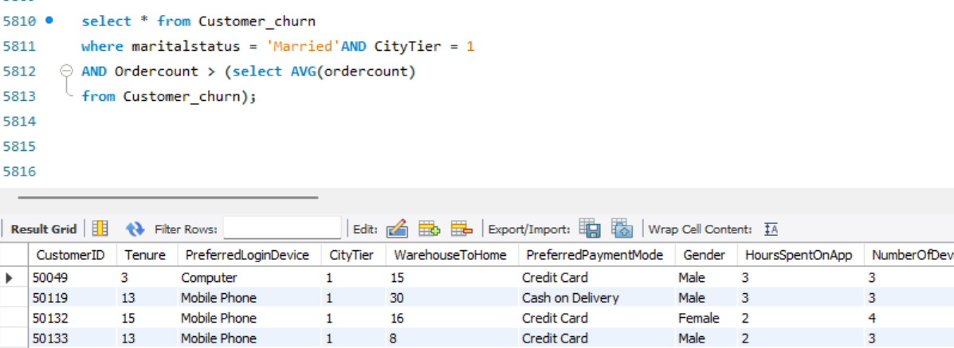

a) Create a ‘customer_returns’ table in the ‘ecomm’ database and insert the following data:

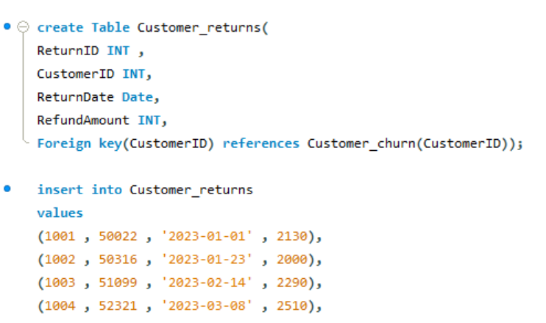
b ) Display the return details along with the customer details of those who have churned and have
made complaints.
Here, I used an INNER JOIN to combine the Customer_returns and Customer_Churn tables using
the common CustomerID. I used the WHERE clause to filter customers who are Churned and have
made complaints. The query displays the return details along with the corresponding customer
details.

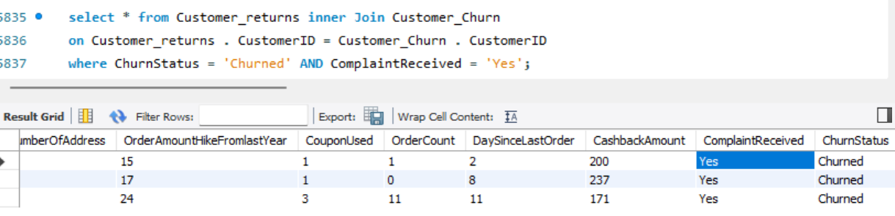

Conclusion

The analysis of the e-commerce customer data provides insights into customer behavior, order patterns, churn status, complaints, and return activities. The data shows differences in churn across customer groups based on factors such as distance from the warehouse, order frequency, payment mode, and customer characteristics. It also identifies customers with complaints and returns among the churned customer group. Overall, the analysis highlights patterns in customer activity and churn that can be useful for understanding customer behaviour and improving customer retention and service strategies.

